- The UHS Insulin Advisor consists of four specific order sets designed to guide the treatment of specific groups of patients using an insulin infusion:
  - Critical Care patients
  - Patients with DKA/HHS
  - Patients who are post-op cardiac surgery
- The UHS Insulin Advisor automatically calculates the optimal insulin infusion rate to bring the patient’s serum BG into normal range. The logic behind the advisor incorporates:
  - The latest POC BG level (from EHR results)
  - The current rate of the insulin infusion
  - When appropriate, i.e., DKA/HHS the most recent serum metabolic values, and
  - When appropriate any carbohydrate consumed, i.e., cardiac surgery patients eating meals, resolved acidosis DKA patients etc.
- Measuring the change in BG level, compared to the current POC BG and the amount of insulin given over the same time period the algorithm recognizes what the next optimal dose would be and “advises” the nurse on what the next dose/rate should be. At times, a bolus dose may also be recommended.
- When using the advisor several essential points must be considered:
  - The algorithm uses the last POC BG entered into the EHR which enters the EHR through “docking” the device. It is essential that the POC device is “docked” for the data to download and transfer into the EHR. If the POC device isn’t docked and the nurse types in the BG value the Advisor doesn’t “see” that value and the bolus dose/infusion rate change may not calculate accurately or safely.
  - All BG values must come from the downloaded POC device. Manual BG entry will result in error.
  - For values above the device thresh-hold (i.e., I-Stat limit of 700 mg/dL), complete a POC reading. If the reading returns > 500 mg/dL start the infusion with the bolus and rate recommended. Greater than 500 mg/dL will enter the EHR from docking the base but not if you attempt to enter the value.
- The algorithm relies on timely measurements, all efforts should be made to ensure that hourly measures are completed and downloaded as close to every 60 minutes as possible.
- The algorithm can be used for patients who are eating; the “prandial” or “meal-time” coverage is based on the percent of the meal the patient consumed:
  - Snacks or < 25%; 25-50% meal consumed or >50% of meal consumed.
  - he prandial insulin should be given within 15 minutes of completing the meal.
- For patients who are eating: use the percent of the meal consumed to administer a prandial dose immediately after eating. DO NOT USE THE INSULIN INFUSION TO CORRECT THE RISE IN BG FOLLOWING THE MEAL, use the recommended SC dose.
- The advisor will adjust the infusion rate in the “post-prandial” state. Continue with q 1 hour POC tests.
- Once the meal consumed is documented the Advisor will indicate what insulin bolus to deliver
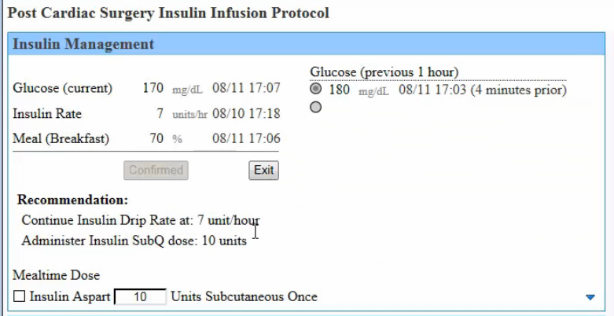
Portion of meal consumed & documented
Dose to cover the carbohydrate bolus
- Deliver all bolus doses using the Alaris pump with guardrails
- If the patient’s BG remains persistently high, check the patency of the IV, confirm no dextrose containing infusions are being delivered and contact the prescriber.
- For transitions to SC insulin the advisors recalls the insulin infusion rates for the previous 24 hours to divide the daily dose between basal and prandial. See below:
- Important Note
- For any unusual, overly high doses or confusing recommendations, please place an Urgent Cerner Support Ticket through Outlook.
  - To: “Support Customer, Corporate”.
  - Subject: “Cerner Ticket, Urgent”

